**PROJECT- 2:**

**AIM: Provisioning EBS volumes and snapshots.**

EBS VOLUME (elastic block storage):

* Amazon Elastic Block Store (EBS) is a block-level storage service offered by Amazon Web Services (AWS). It provides persistent block storage volumes that can be attached to Amazon EC2 instances.
* EBS offers different types of volumes for storage.
* General Purpose SSD: Provides a balance of price and performance for a wide range of workloads.
* Provisioned IOPS SSD: Designed for high-performance, low-latency applications that require consistent I/O performance.
* Throughput Optimized HDD: Optimized for frequently accessed, throughput-intensive workloads.
* Cold HDD: Designed for less frequently accessed, throughput-intensive workloads at a lower cost.
* Magnetic: The original EBS volume type with lower performance characteristics and lower cost.

SNAPSHOT:

* In Amazon Web Services (AWS), a snapshot refers to copy of an Amazon Elastic Block Store (EBS) volume. It captures the data and configuration of the volume at the time the snapshot is taken.
* Snapshots are primarily used for data backup and recovery purposes. Snapshots allow you to restore EBS volumes to a previous state by creating a new volume from a snapshot.

Working with EC2 AND EBS:

Steps:

1.First we need to launch an instance. So, we need to provide our instance a name.

2.We Should select the AMI as ubuntu 22.04 LTS.

* In AWS (Amazon Web Services), AMI stands for Amazon Machine Image. An AMI is a pre-configured template that contains the necessary information to launch an instance (virtual server) in the AWS cloud. It includes the operating system, software, and any additional data required to run an application.

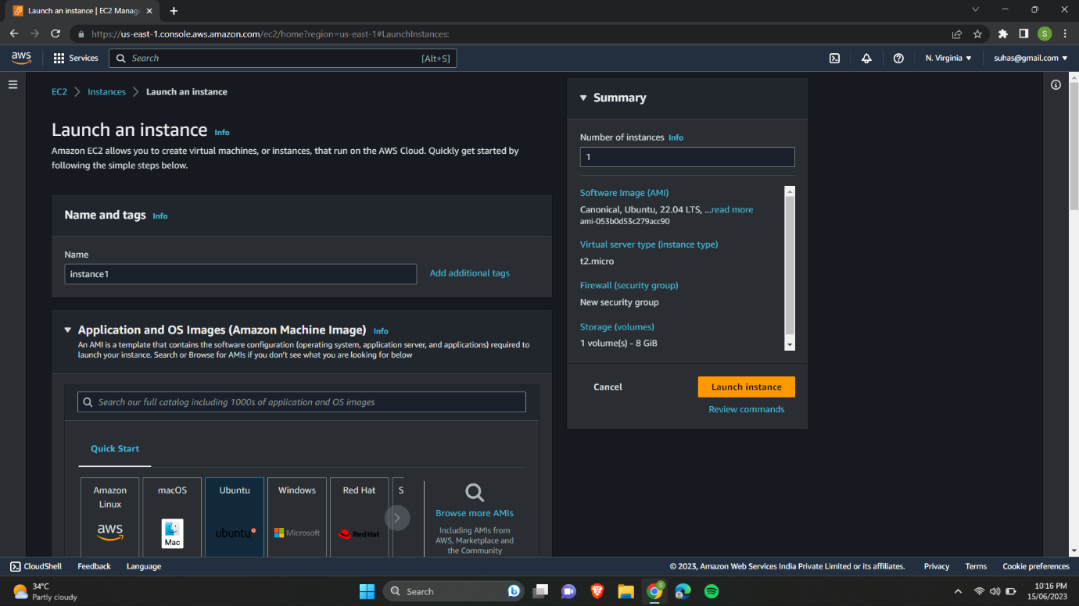

3.Selecting the instance type as t2.micro and selecting the keypair.

* In AWS (Amazon Web Services), an instance type refers to a specific configuration of virtual hardware resources that are allocated to an Amazon EC2 (Elastic Compute Cloud) instance. Each instance type has varying combinations of CPU, memory, storage, and networking capacity to meet different workload requirements.
* In AWS (Amazon Web Services), a key pair is a secure key-based authentication method used to securely connect to instances running in Amazon EC2 (Elastic Compute Cloud). It consists of a public key and a corresponding private key.

4.We are going to edit the network settings and configuring the security group.

* In AWS (Amazon Web Services), a security group is a fundamental component of network security that acts as a virtual firewall for your EC2 (Elastic Compute Cloud) instances. It controls inbound and outbound traffic to and from your instances.
* In this case we are selecting the security group which allows only SSH requests.
* In this case we are selecting the us-east -1a availability zone.

5.After launching the instance it is visible as below.

6.Again we are launching another instance but this time in different availability zone.

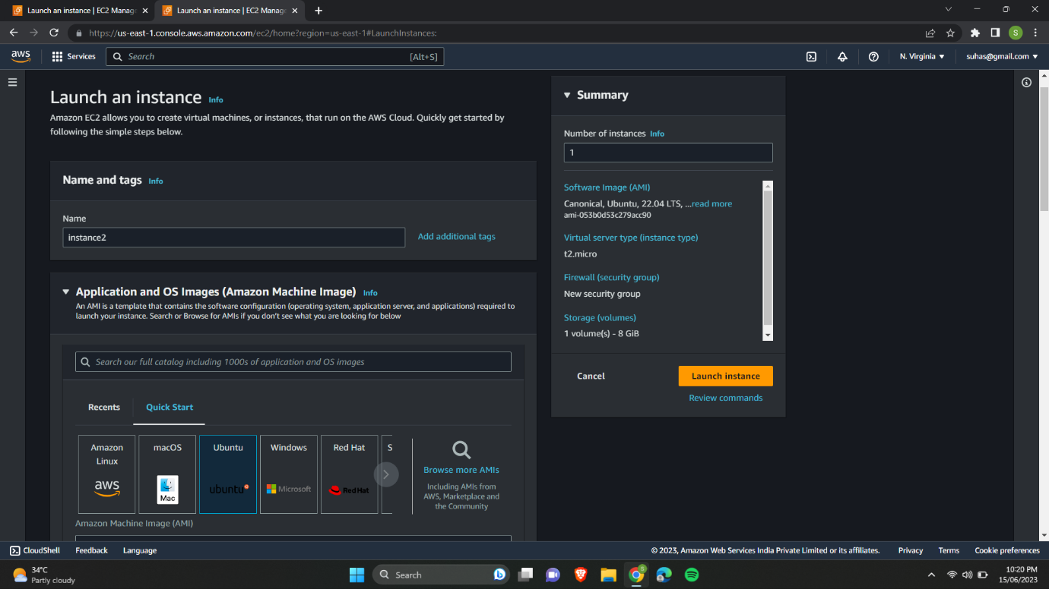

7.Selecting the instance type as t2.micro and selecting the keypair.

8.In the network settings we are going to choose us-east-1b as the availability zone and launching the instance.

9.creating an EBS volume for instance1 with size 1 GB.

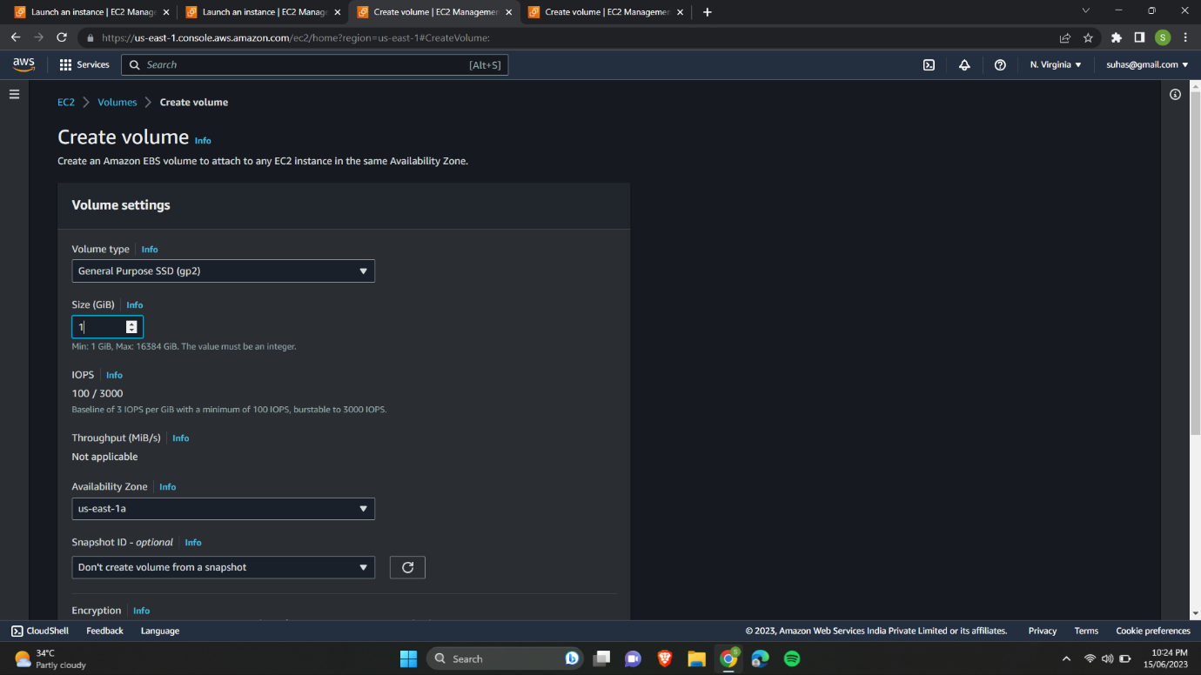

10.Select the EBS volume and click on attach volume option.

11.You can see instance1 in the dropdown because you have created in us-east-1a availability zone. Attach the volume.

12.Select the EBS volume and choose create snapshot option.

13.Now we need to create volume from the snapshot.

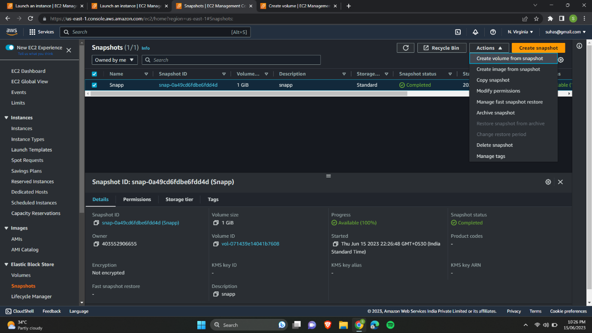

14.while creating choose the availability zone ad us-east-1b as instance2 present here.

15.select the volume created from the snapshot and attach the volume to instance2.

16.We can check whether the volumes are attached to our instances or not by selecting the instances and checking the storage info.

17.Al last you will be able to see 2instances,4volumes, and a snapshot.

# Creating a file in EBS data volume:

Steps:

* Check if the EBS volume is already mounted on the instance using the lsblk command. If it is not already mounted, you need to mount it to a specific directory on your EC2 instance.

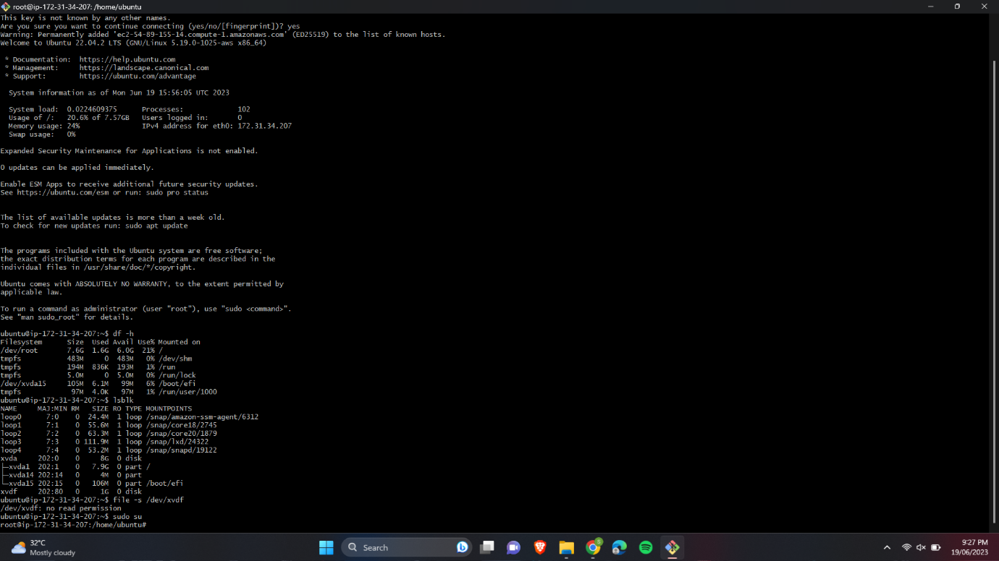

* Run the command lsblk to view the available block devices. Identify your EBS volume from the list, usually named /dev/xvdf or similar.

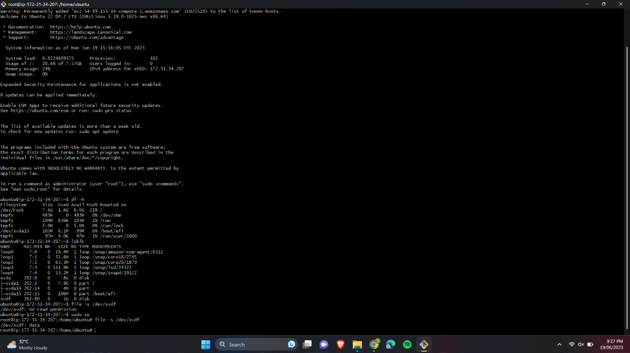

* Choose a directory on your EC2 instance where you want to mount the EBS volume.

* Use the command sudo mount /dev/xvdf /ebs (replace /dev/xvdf with the appropriate device name for your volume) to mount the EBS volume to the chosen directory.

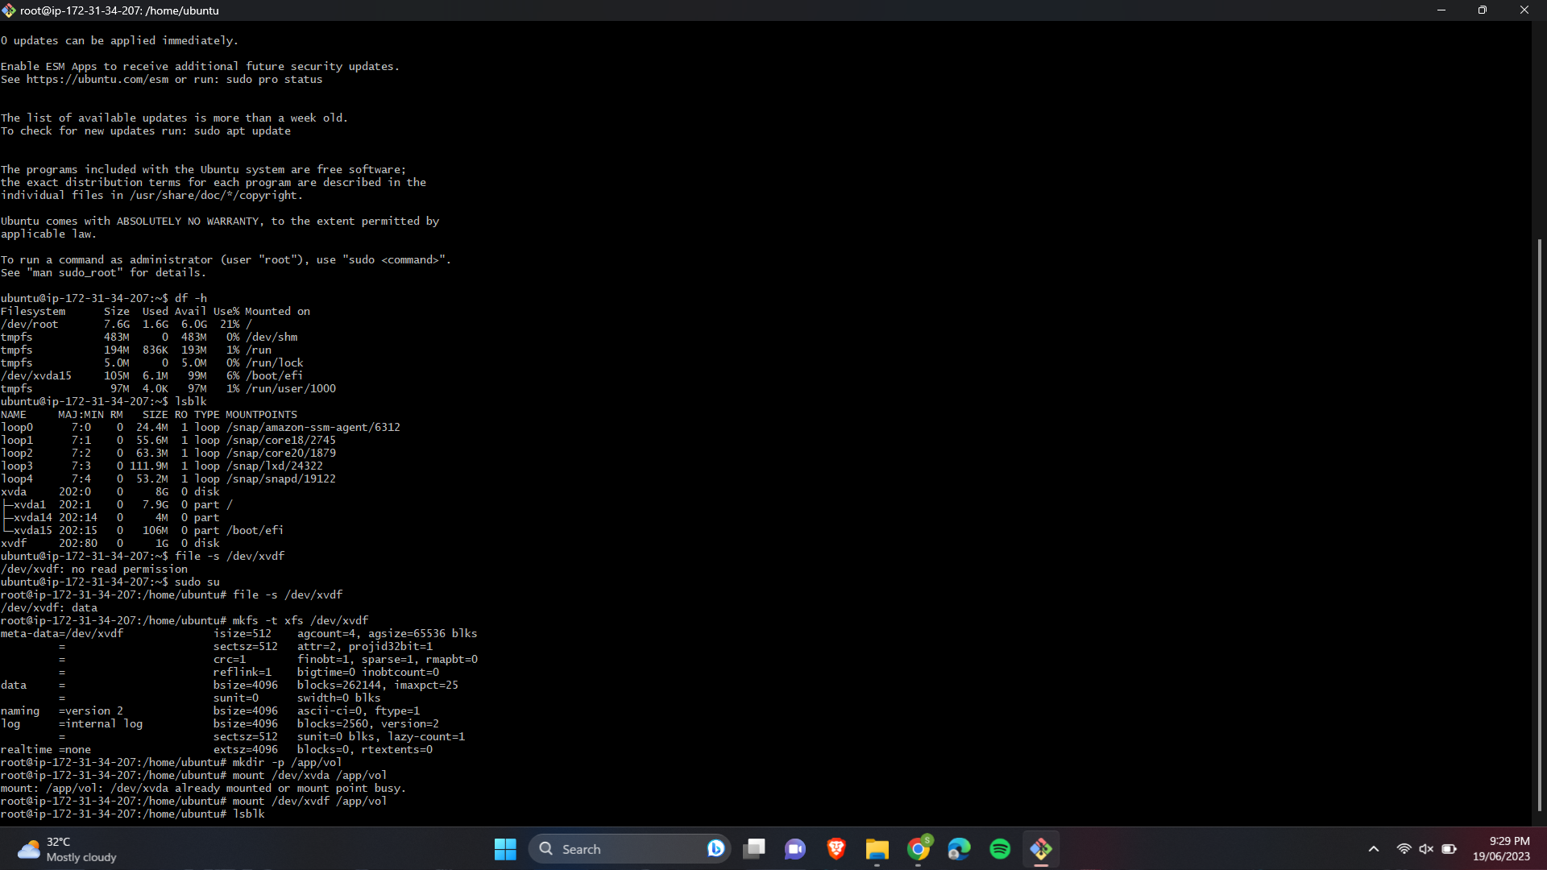

* Change to the directory where you mounted the EBS volume. Once you are in the mounted directory, you can create a file.

